**Advanced Database - TP 2**

**Advanced SQL**

### 

**Exercice 1. Analytics Queries . Window Queries**

If you don’t remember about Analytical / Windows Queries, please [re-read this chapter](https://docs.google.com/presentation/d/1e1dlRYzntEZLSV4ol0EYb3ZYTcXl_mAZlawMpxnfcWk/edit#slide=id.g4d04feb32d_16_0).

1. Gets the 2 persons per department, who have arrived the latest in the company.

2. Show your analytical Skill and Invents an interesting query using Windows Functions (i.e.: a SELECT query on EMP table): The query should include the usage of “ROWS BETWEEN 1 PRECEDING AND 1 FOLLOWING”.

**Exercice 2. Index & Explain Plan**

In this Exercise, we are going to use an Index to speed UP drastically a query.

We’ll see it’s difficult to take time into account for performance when analyzing a query. Because it depends on many factors: CPU, RAM, and most important if your results are already in CACHE or not (if you execute a query N time in a row, the first time it will be slow, then very quick because in CACHE).

1. Execute this script (create 3 tables and load random data inside):

|  |
| --- |
| ------------------------------------------  ------------ Create Employee Table -------  ------------------------------------------  CREATE TABLE EMP_MEDIUM_TABLE  (EMPNO NUMBER(10),  MANAGER_ID NUMBER(10),  DEPTID VARCHAR2(10),  GENDER VARCHAR2(2) not null,  NAME VARCHAR2(1000));  INSERT INTO EMP_MEDIUM_TABLE  SELECT LEVEL empl_id,  TRUNC (DBMS_RANDOM.VALUE (1, 100), 0) manager_id,  MOD (ROWNUM, 50000) dept_id,  DECODE (ROUND (DBMS_RANDOM.VALUE (1, 2)), 1, 'M', 2, 'F') gender,  DBMS_RANDOM.STRING ('x', DBMS_RANDOM.VALUE (20, 50)) name  FROM DUAL  CONNECT BY LEVEL <= 50000;  ------------------------------------------  ------------ Create Project Table --------  ------------------------------------------  CREATE TABLE PROJECT_MEDIUM_TABLE  (PROJECTNO NUMBER(10),  NAME VARCHAR(100));  INSERT INTO PROJECT_MEDIUM_TABLE  SELECT LEVEL PROJECTNO,  DBMS_RANDOM.STRING ('x', DBMS_RANDOM.VALUE (20, 50)) name  FROM DUAL  CONNECT BY LEVEL <= 50000;  ------------------------------------------  ---- Create Join table: Project-Employee -  ------------------------------------------  CREATE TABLE PROJECT_EMP_MEDIUM_TABLE  (PROJECTNO NUMBER(10),  EMPNO VARCHAR(100));  INSERT INTO PROJECT_EMP_MEDIUM_TABLE  SELECT TRUNC (DBMS_RANDOM.VALUE (1, 100), 0) PROJECTNO,  TRUNC (DBMS_RANDOM.VALUE (1, 100), 0) EMPNO  FROM DUAL  CONNECT BY LEVEL <= 50000; |

2. The goal of all exercice will be to tune the following query:

|  |
| --- |
| SELECT gender, count(*) from EMP_MEDIUM_TABLE where MANAGER_ID = 7 group by gender; |

Execute it and Note the response time.

Note: Response Time in second is not really a good metric to analyze queries. Because this number will depends on many external parameters than the query:

* Hardware of the machine: CPU, RAM, Disk Read Speed (SSD is faster than HDD), network…,
* Number of persons connected to the Oracle Server, number of queries in parallel ...

That’s why we’ll find others more precise metrics: I/O, CPU time, ‘Consistent Gets’, etc...

3.1. Use EXPLAIN plan to analyze the query:

|  |
| --- |
| EXPLAIN PLAN FOR SELECT gender, count(*) from EMP_MEDIUM_TABLE where MANAGER_ID = 7 group by gender;  SELECT * FROM PLAN_TABLE; |

Keep the Execution Plan for this query

3.2. **Get Stats with Autrace**

Note: If you are using a connection to ISEP server, it won’t work unless you ask the teacher for special rights to the teacher. If you have installed your personal Oracle Express, you are admin, so it’s ok.

The goal is to find the number of ‘Consistent Gets’, a very important metric ([More info here](http://www.dba-oracle.com/m_consistent_gets.htm)).

* If you use SQLDeveloper as a client: you should select the query and then click on the ‘Autotrace’ button (In French: “Enregistrer la trace automatiquement”):

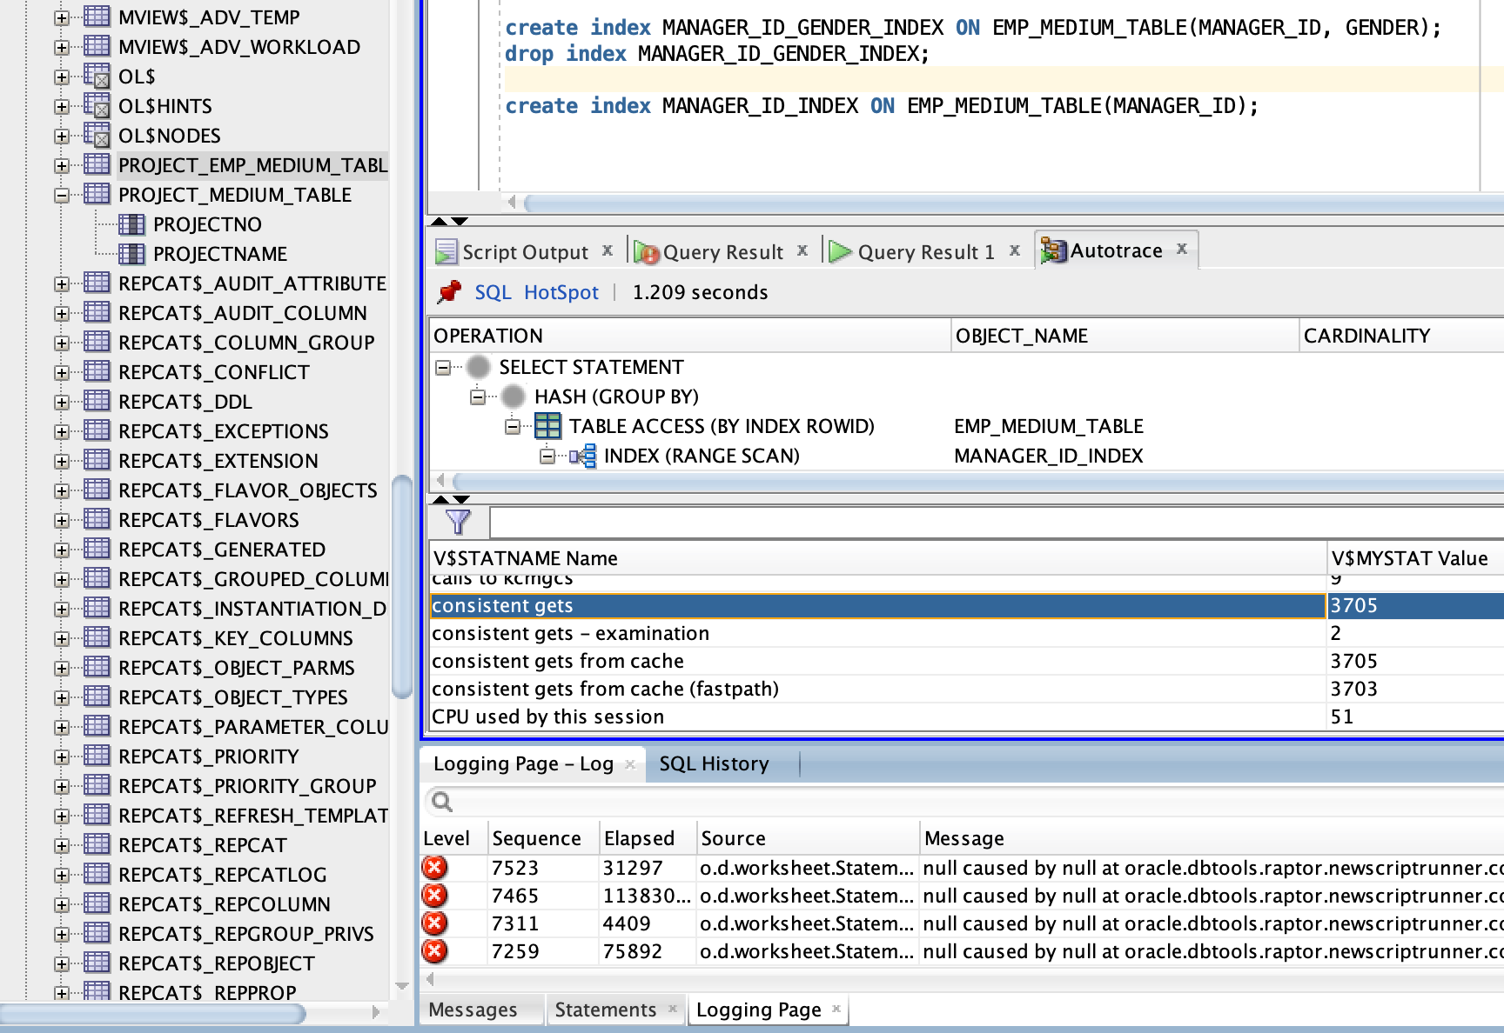

* If you use SqlPlus as a client (the display is easier with Sqlplus for Autrace). Run this:

|  |
| --- |
| set autotrace traceonly timing on; |

*Warning*: This line only in sqlplus, not SQLDeveloper.

Then run the query to analyze.

You’ll see very quickly the number of Consistent Get.

4. Add a **covering index** on both columns fetched:

|  |
| --- |
| create index MANAGER_ID_GENDER_INDEX ON EMP_MEDIUM_TABLE(MANAGER_ID, GENDER); |

5. Re-run query the same query:

|  |
| --- |
| SELECT gender, count(*) from EMP_MEDIUM_TABLE where MANAGER_ID = 7 group by gender; |

Note the response time.

6. Use EXPLAIN plan again / Get the number of “consistent Gets” and compare with results before adding indexes.

7. (Bonus - Difficult Question) Using the 3 tables, find a query that take a huge amount of time (more than several seconds) without Index and when you add index, it significantly improves the response time (at least 10 times).

**Exercice 3. Data Dictionary**

*The data dictionary is a set of tables that store descriptions of database objects. A user can access the data dictionary through views (USER_TABLES, USER_VIEWS, USER_SYNONYMS, USER_CONSTRAINTS, USER_TRIGGERS,etc.).*

Use these views to create a table called MY_OBJECTS with 2 columns : Object (Name of your Object) / Type (Table, column, constraint …).

This will look like that:

|  |  |
| --- | --- |
| **Object** | **Type** |
| EMP | Table |
| EMPNO | Column |
| PK_EMP | Constraint |

**Exercice 4. Use SqlPLus**

*Here you will see that you can manipulate the Database with a simple shell.*

0. Install sqlPlus: TODO (Add Tutorial - If someone has a tutorial for a standalone install, please add it here)

* On Mac: ([install HomeBrew first](https://brew.sh/index_fr)): <https://vanwollingen.nl/install-oracle-instant-client-and-sqlplus-using-homebrew-a233ce224bf>
* On Windows: <https://www.oratable.com/sqlplus-instant-client-installation/>
* On your Own Linux (with Admin/sudo Right): <https://askubuntu.com/a/207145>
* On ISEP Linux (not admin on computer, so no sudo rights): TODO add tutorial (Advanced as there is not yet specific tutorial available for ISEP computers).



1. Open the terminal and launch a session with sqlPlus (replace the 5 attributes yourUserName, yourPassword, hostname, prt, SID):Example, Here is the URL for the

|  |
| --- |
| sqlplus yourUserName/yourPassword@hostname:port/SID |

one using Oracle with the Docker install:

|  |
| --- |
| sqlplus system/oracle@localhost:49161/xe |

2. On sqlPlus: Launch a

|  |
| --- |
| SELECT * FROM EMP; |

If the display is not nice, use the following settings: <https://stackoverflow.com/a/5771611>

Re-run the query to have a nicer result.

**Exercice 5. Transaction Part 1 - Beginner**

0. Open 2 sql clients on the same Database.

For this Exercise, you should have 2 clients:

* Either 2 SQLDeveloper open.
  + On Linux, it’s possible to open several SQLDeveloepr
  + On Mac, to open another SQLDeveloepr, open a Terminal and run

‘sh /Applications/SQLDeveloper.app/Contents/Resources/sqldeveloper/sqldeveloper.sh

* + On Windows: Open SQL Developer as an administrator will open a second client.
* Or 1 SQLDeveloper + 1 SqlPlus Session.
* Or 2 SqlPlus Sessions.

1. **Be sure to have autocommit disabled (default behaviour in SQL). Just in case run this command:**

|  |
| --- |
| set autocommit off; |

2. **On the first client**: Launch:

|  |
| --- |
| UPDATE EMP SET SAL = 5000 WHERE EMPNO = 7369 |

3. **On the first client**, launch:

|  |
| --- |
| SELECT * FROM EMP |

Can you see the UPDATE of the salary for the employee ?

4. **On the second client**, launch:

|  |
| --- |
| SELECT * FROM EMP |

Can you see the UPDATE of the salary for the employee ? Why ? How can you make the update available for the second client ?

**Exercice 6. Transaction Part 2 && GRANT rights - Advanced**

This exercise must be conducted in collaboration with a second user close to the used workstation. The report will provide the script queries and the effect of these queries. (Example: change impossible, insufficient privileges, user waiting or queuing user).

Consider two users U1 and U2, the user U1 owns the EMP and DEPT tables. Users U1 and U2 perform in the specified order the following queries:

0. Create user U2

1. U2 tries to access the EMP table belonging to U1

2. U1 grants privileges to U2 to be able to read EMP and DEPT

3. U1 update his table EMP by changing COMM from 800 to 700

4. U2 select all the employees with COMM=700

5. U1 executes a COMMIT

6. Deadlock:

a. U1 updates the tuple i (choose one) from EMP

b. U2 updates the tuple j (choose one) from DEPT

c. U1 updates the tuple j from DEPT

d. U2 updates the tuple I from EMP

Propose a solution to the deadlock

7. Remove privileges previously granted and ensure that the privileges have been removed